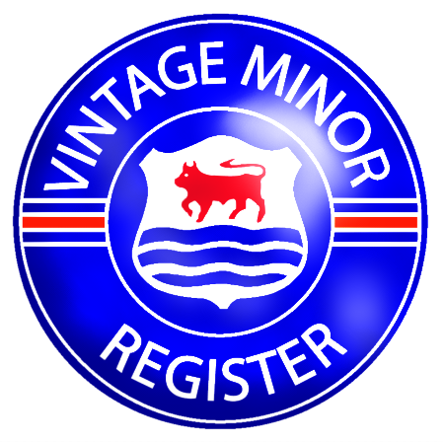

The Vintage Minor Register

13416 Kellogg Lake Road (+01) 360/348/5436
Sultan vintageminor@gmail.com
WA98294, USA www.vintageminor.co.uk

The VMR Summer Rally, 20th to 22nd July 2012

(Please return this form with your payment to the above address by 30th June 2012)

Name, address, tel. no., e-mail: ____________________________________________

_______________________________________________________________________

Vehicle make, model and year: _______________________ Registration number: _________

Pre-War Prescott - Garden Party and Day of Untimed Climbs, Prescott, Saturday 21st July

I wish to order ________ tickets £ _________

(£20-00 per car including one free climb for VMR members, £30-00 for non-members, including all occupants)

I wish to order ________ climb tickets in advance (£5-00 per climb) £ _________

(In the event of oversubscription on the day, those holding advance tickets will receive priority on the hill)

I would be willing to marshal at Prescott for 2 hours: YES / NO

The Swinging Forties Night and BBQ with Fiona Harrison, Prescott, Saturday 21st July

I wish to order ________ tickets (£15-00 per person) £ _________

The Cotswold Navigation Rally/Scenic Tour, Sunday 22nd July

I wish to enter the Navigation Rally (£20-00 per car) £ _________

I wish to enter the Scenic Tour (£20-00 per car) £ _________

I wish to order _______ Navigation Rally/Scenic Tour cream teas (£6-00 per person) £ _________

I would be willing to marshal on the Navigation Rally for 2 hours: YES / NO

(Note: ALL vehicles competing in the Sunday Navigation Rally/Tour MUST carry a current MoT and road insurance.)

I enclose a cheque payable to Ian Grace for: £ _________

Tickets for all the above activities and Final Instructions for the Navigation Rally will be posted to entrants in advance of the weekend. Full accommodation details for local hotels and guesthouses may be found on the VMR website, or can be provided on request to the Register at the above address.

The Small Print

All information on this entry form is given in good faith at the time of publication but may be altered due to unforeseen circumstances. We regret no refunds can be made. The VMR reserves the right to alter or cancel the programme without notice.

